

Year 1 Autumn 2 Home Learning
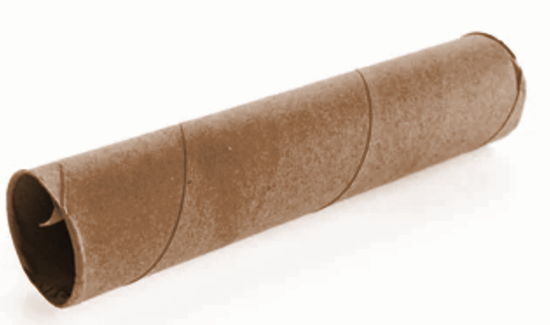
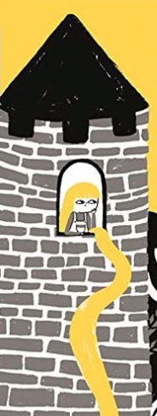
Welcome back to our Autumn 2 half term. Below you will find all the homework for the next half term, including Reading, Maths and Literacy for each week. On Fridays your child will come home with a homework book which they can do the work in, please bring this back in by WEDNESDAY each week.
In DT this half term we will be building model towers inspired by the story of Rapunzel.
If you have any finished tubes of kitchen roll or wrapping paper at home, please could you bring them into school?
Thank you!

Reading Books:
Your child will come home on THURSDAYS with new books. One RWI paper reading book and one other reading book. Please try to read as often as possible, as this truly is the key skill they need to succeed in Year One. Please keep all books together in the plastic wallet provided and keep these in their blue school bags each day, particularly THURSDAYs as this is when they are changed. They will read every day in their RWI lesson and will have further reading with their class teacher, TA and other adults throughout the week.

Week 1: Friday 7th November – Wednesday 12th November
Home Learning  Reading | Home Learning  Maths | Home Learning  Spelling & Vocabulary
You need to listen to your child read for at least 10 minutes each day 5 times a week.  To help them understand what they are reading talk together about the book.  If you wish to ask them questions about what they are reading this will help them to develop their comprehension skills. | Maths Focus for this week is:  Number bonds to 10. Using Part part whole models.  Things to do at home:  Find 10 objects and record number sentences using addition and equals symbols. Example: 4+5=9. (Numbers within 10 only) | Star Words:  He, she, of, our, do  Your child should be able to read and spell these words independently. You can use then as flash cards and write sentences into the homework books.

Week 2: Friday 14th November – Wednesday 19th November
Home Learning  Reading | Home Learning  Maths | Home Learning  Writing, Spelling & Vocab
You need to listen to your child read for at least 10 minutes each day 5 times a week.  To help them understand what they are reading talk together about the book.  If you wish to ask them questions about what they are reading this will help them to develop their comprehension skills. | Maths Focus for this week is:  Subtraction within ten  Things to do at home:  Practise subtracting different amounts - use objects or crossing out images for support (up to 10).  Practice number bonds up to ten. | Star Words:  Review: he, she, of, our, do  Write a recount of your weekend.  Use ‘First, Then, Next, After that, Finally’ to order the events.  Too tricky? Write a simple sentence about one thing you did at the weekend.

Week 3: Friday 21st November – Wednesday 26th November
Home Learning  Reading | Home Learning  Maths | Home Learning  Writing, Spelling & Vocab
You need to listen to your child read for at least 10 minutes each day 5 times a week.  To help them understand what they are reading, talk together about the book.  If you wish to ask them questions about what they are reading this will help them to develop their comprehension skills. | Maths Focus for this week is:  Counting backwards from 10. Use a numberline.  Things to do at home:  Practise counting backwards. Use items to help.  Draw a numberline and practise counting back from different numbers. | Star Words:  Ask, are, today, no, says  Your child should be able to read and spell these words independently. You can use then as flash cards and write sentences into the homework books.

Week 4 – Friday 28th November – Wednesday 3rd December
Home Learning  Reading | Home Learning  Maths | Home Learning  Writing, Spelling & Vocab
You need to listen to your child read for at least 10 minutes each day 5 times a week.  To help them understand what they are reading, talk together about the book.  If you wish to ask them questions about what they are reading this will help them to develop their comprehension skills. | Maths Focus for this week is:  Addition and subtraction within 10  Things to do at home:  Practise word problems for addition and subtraction. For example:  Jo has 4 apples and Sue has 6, how many do they have altogether?  Ben has 7 sweets and gives 3 away, how many does he have left? | Star Words:  Review: Ask, are, today, no, says  ‘Signs of winter’  Write down some tell-tale signs that tells us it is winter and colour in the winter picture.

Week 5: - Friday 5th December – Wednesday 10th December
Home Learning  Reading | Home Learning  Maths | Home Learning  Spelling & Vocabulary
You need to listen to your child read for at least 10 minutes each day 5 times a week.  To help them understand what they are reading, talk together about the book.  If you wish to ask them questions about what they are reading this will help them to develop their comprehension skills. | Maths Focus for this week is:  2D Shapes.  Things to do at home:  Go on a shape hunt around the house. This is just 2D shapes this week (3D next week). Try to find a circle, square, triangle, rectangle.  Talk about how many sides and corners they have.  Draw some examples in your HW book. | Star Words:  Where, were, your, go, so  Your child should be able to read and spell these words independently. You can use then as flash cards and write sentences into the homework books.

Week 6 – Friday 12th December – Wednesday 17th December
Home Learning  Reading | Home Learning  Maths | Home Learning  Writing, Spelling & Vocab
You need to listen to your child read for at least 10 minutes each day 5 times a week.  To help them understand what they are reading, talk together about the book.  If you wish to ask them questions about what they are reading this will help them to develop their comprehension skills. | Maths Focus for this week is:  3D Shapes  Things to do at home:  Go on a shape hunt for 3D shapes. Try to find a sphere, cube, cuboid, cylinder, cone and pyramid.  Talk about how many edges and vertices. Take pictures and stick in HW book. | Star Words:  Review Where, were, your, go, so  Your child should be able to read and spell these words independently. You can use then as flash cards and write sentences into the homework books.

Christmas
We finish for Christmas break on Thursday 18th December.
Have a wonderful Christmas break - enjoy yourselves!
With best wishes for a very merry Christmas.
From the Year 1 Team x

